**BRIDGE TABLE:**

* A bridge table enables you to resolve many-to-many relationships

between tables.

* Bridge table is also known as helper table or reference table.
* A logical data model may contain one or more many-to-many relationships.

* Physical data modeling techniques transform many-to-many many-relationships into one-to many-relationships by adding additional tables. These are referred to as bridge tables.
* The key difference between a bridge table and a fact table is that the bridge table relationship is mandatory.
* The bridge table relationship restricts the data from one subject area based on the records that are returned from another subject area.
* A fact table does not provide this restriction because the other two data sets operate as non-conformed dimensions. A filter that is applied to one data set has no impact on the other data set.

**Benefits to creating bridge tables:**

* Properly joining the data streams that exist on each side of the bridge.
* Filtering both data streams when a filter is applied on only one stream. If the data from one stream is properly associated with the other stream, applying a filter on any column filters out a whole row of data. You can use detail filters and summary filters.
* Avoiding double counting.
* Dimensional designs often need to accommodate multivalued dimensions. Patients can have multiple diagnoses. Students can have multiple majors. Consumers can have multiple hobbies or interests. Commercial customers can have multiple industry classifications. Employees can have multiple skills or certifications. Products can have multiple optional features. Bank accounts can have multiple customers. The multivalued dimension challenge is a natural and unavoidable cross-industry dilemma.
* A common approach for handling multivalued dimensions is to introduce a bridge table.

**Example:**

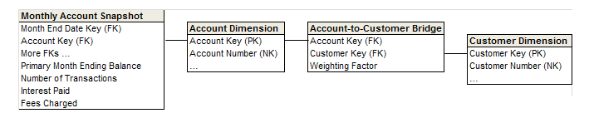

The following figure shows a bridge table to associate multiple customers with an account.

* In this case, the bridge contains one row for each customer associated with an account. Similarly, a bridge table might have one row for each skill in an employee’s group of skills. Or one row for each option in a bundle of product features.

**Example:**

A patient has many diagnoses

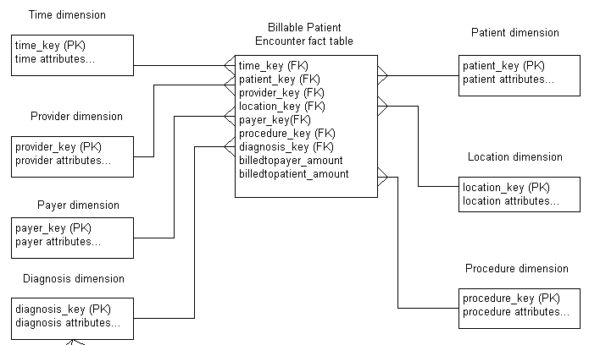

* **Problems**
* When retrieving measures from fact table from a dimension, we need a *Weighting Factor*
* Otherwise, incorrect result when more than one dimension factor is in effect
* Looking for rows where a particular combination of diagnosis was related requires multiple correlated sub queries
* Report generation is much more complex
* Need more join
* **Approach: Use Bridge table**

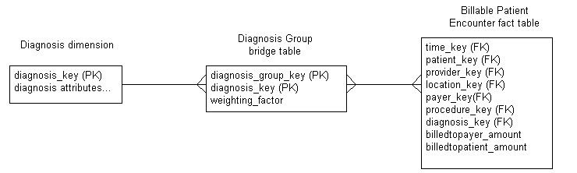

* Diagnosis_group_key, Diagnosis_key, Weighting_factor
* Within each diagnosis group: Sum(Weighting_factor) = 1
* Two types of reports:
  + Weighted summary of all charges
  + *Impact report*that does not use the weighting factor
* When a patient will have different diagnosis groups over a period of time:
  + Add patient_key, begin_date, end_date
  + Why do we need patient_key?
  + The PK could be Diagnosis_group_key + Diagnosis_key + Begin_date

**Example:**

* For example, you have a model that contains two star schemas that represent real estate properties and property owners.
* Multiple properties are owned and shared between multiple owners.
* The property owner’s schema contains two query subjects, OWNER and OWNER_FACT.
* The properties schema contains two query subjects, PROPERTY and PROPERTY_FACT.
* Add a bridge table to capture the many-to-many relationship between the OWNER and the PROPERTY tables.
* The bridge table contains the OWNER_ID and PROPERTY_ID query items. It also contains other query items that provide context or meaning to the relationship, such as share_percentage.
* The cardinality of the bridge table is [1..n] in both relationships and the cardinality of the OWNER and PROPERTY tables is [1..n].

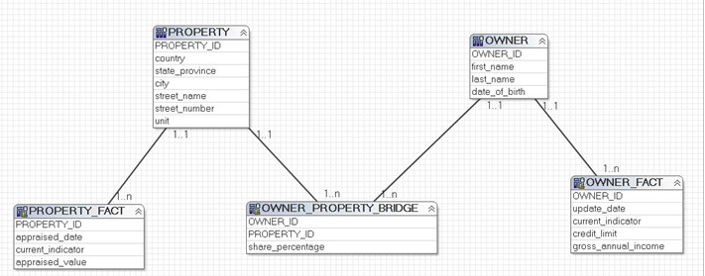

* An owner may own several properties.
* A property may have several owners.
* A property may have several maintenance contracts with the same contractor.